Pass Task 14 – Case Study

# Related Learning Outcomes

# ULO1 – Explain the OO Principles

This exercise demonstrated object encapsulation teaching me about how you can make features either public or private to only exist within the object. The topic taught me to convert abstract plans such as UML diagrams into actual code to use. The exercise used a lot of polymorphism to share similar methods and fields that classes shared from the GameObject to the Identifiable Object and down to the specialized fields of Inventory, Player and Item.

# ULO2 – Use OO Language and Library

Demonstrated class and constructor declaration, the use of conditional statements (e.g. “if”), and assigning values to parameters. The task examines how fields can be used by an object to remember information. We used a Property to get the name and value from the counter and be able to access it outside the object. The task had using System.Collections.Generic to access the Lists.

# ULO3 – Design, Develop and Test using an IDE

The code was developed using Xamarin Studio to build and run the program, as well as integrated debugging features to step and inspect values. Nunit was used for the unit testing to make sure the code was functioning correctly.

# ULO4 – Communicate using UML Diagrams

I learned how to interpret a UML class diagram and write the related code. The task had multiple UML diagrams including sequence diagrams which we had to interpret and then convert into code.

# ULO5 – Describe Elements of Good OO Design

The exercise demonstrated correct use of C# coding conventions including proper naming, syntax and correct layout.

# Screenshots

[code tested]

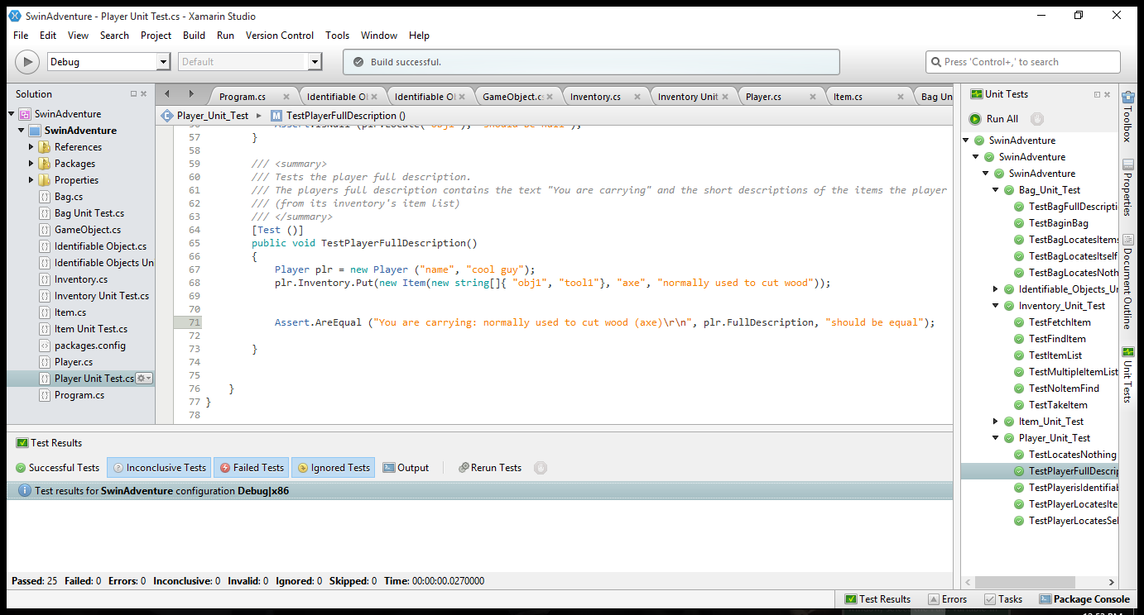

[use of IDE]

